1) Select the set in which the numbers are related in the same way as are the numbers of the following set.

**(25, 35, 30)**

**(40, 10, 25)**

a) (18, 30, 25)

b) (50, 60, 55)

c) (12, 36, 18)

d) (72, 48, 64)

Ans. b

Sol.

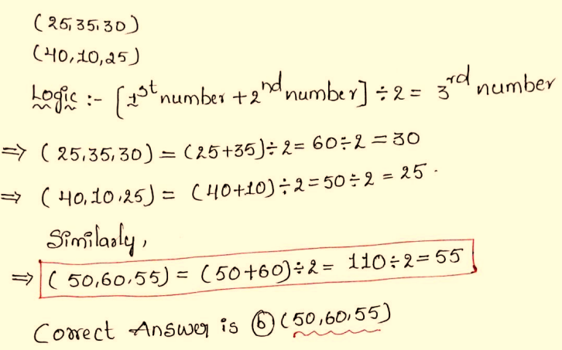

2) Four letter-clusters have been given out of which three are alike in some manner and one is different. Select the one that is different.

a) RQA

b) KJT

c) DEM

d) NMW

Ans. c

Sol.

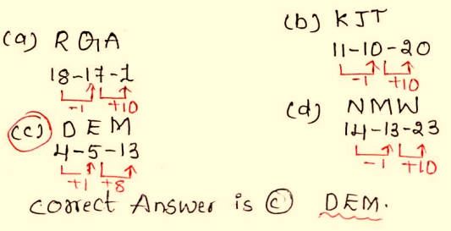

3) In the question below, a statement is followed by two conclusions based on the statement. Study the conclusions and select the correct option as the answer.

**Statement:** H ≤ B < O > R ; Y = O ≥ E

**Conclusions:** I: H ≤ E

II: B ≤ Y

a) Only II follows

b) Only I follows

c) Both I and II follow

d) Neither I nor II follows

Ans. d

Sol.

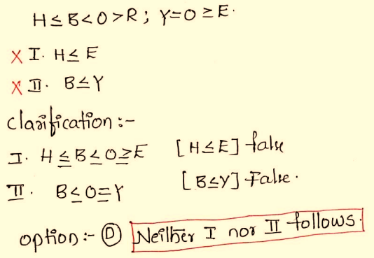

4) In a certain code language, ‘**GRASP**’ is written as ‘**HSZTQ**’ and ‘**ASKED**’ is written as ‘**ZTLVE**’. How will ‘**HUNTS**’ be written in that language?

a) IVOUT

b) IFOUT

c) SFMUT

d) IFMUT

Ans. b

Sol.

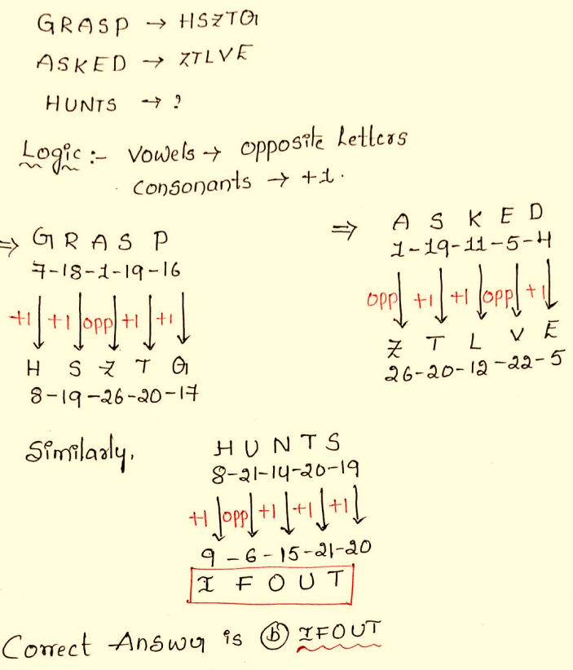

5) A paper is folded and cut as shown below. How will it appear when unfolded?

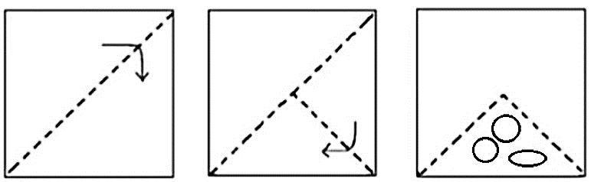

a) 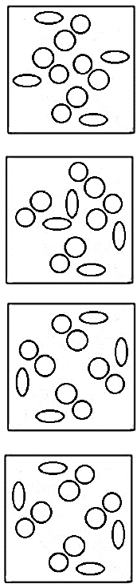

b) 

c) 

d) 

Ans. d

Sol.

After cutting and unfolding the paper, we get:

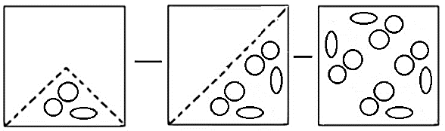

Hence, option d.

6) Select the option in which the following figure is embedded. (Rotation is NOT allowed).



a) 

b) 

c) 

d) 

Ans. b

Sol.

Here, the given figure is embedded in Figure (B).

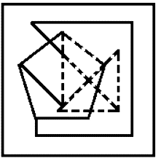

7) Three different positions of the same dice are shown. Study the same and identify which of the following statement/s is/are correct.

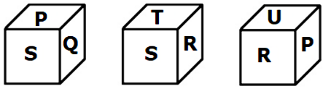

I. S is opposite to U

II. T is opposite to S

III. R is opposite to Q

IV. P is opposite to U

a) Only I

b) Only I and III

c) Only II

d) Only II and IV

Ans. b

Sol.

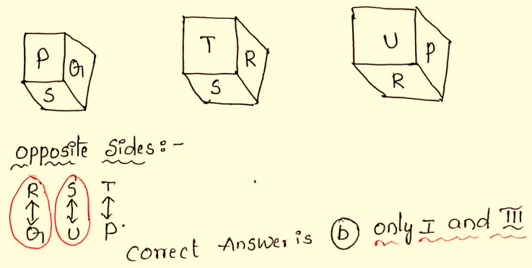

8) Select the correct combination of mathematical signs to sequentially replace the * signs and balance the given equation.

**90 * 45 * 15 * 3 * 12 = 93**

a) ÷, +, -, ×

b) -, ÷, ×, +

c) ÷, ×, +, -

d) +, -, ×, ÷

Ans. b

Sol.

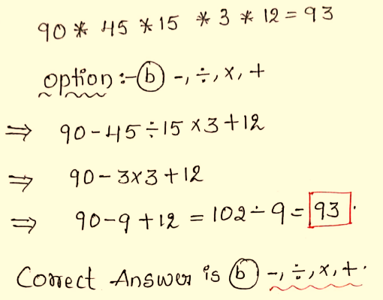

9) Which of the following numbers will replace the question mark(?) in the given series?

**4, 10, 24, 50, ?, 210, 424**

a) 104

b) 96

c) 122

d) 136

Ans. a

Sol.

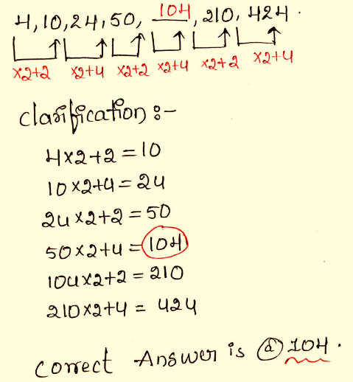

10) In this question, three statements are given, followed by two conclusions numbered I and II. Assuming the statements to be true, even if they seem to be at variance with commonly known facts, decide which of the conclusions logically follows/follow from the statements.

**Statements:**

Some Smile is Smirk

No Smirk is Beam

Some Beam is Light

**Conclusions:**

I. Some Smile is not Beam

II. No Smirk is Light

a) Only conclusion I follows

b) Only conclusion II follows

c) Both conclusions I and II follow

d) Neither conclusion I nor II follows

Ans. a

Sol.

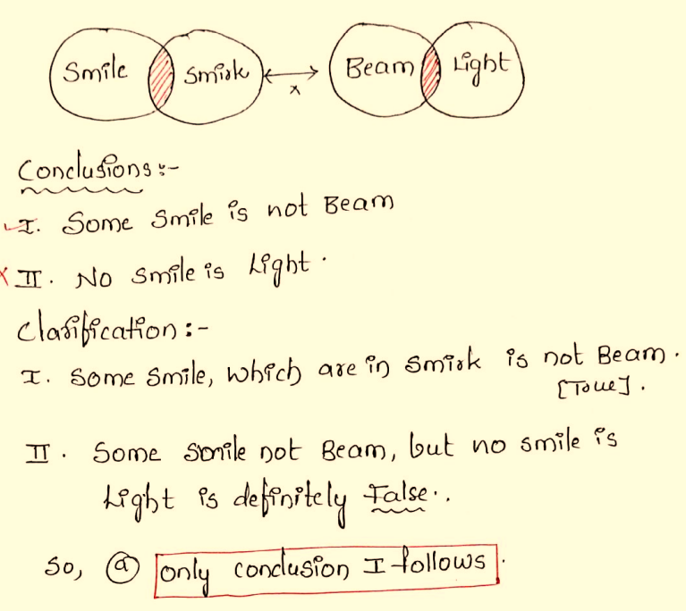

11) Select the option that is related to the fourth number in the same way as the first number is related to the second number and the fifth number is related to the sixth number.

**84 : 3 :: ? : 5 :: 260 : 4**

a) 625

b) 630

c) 640

d) 635

Ans. b

Sol.

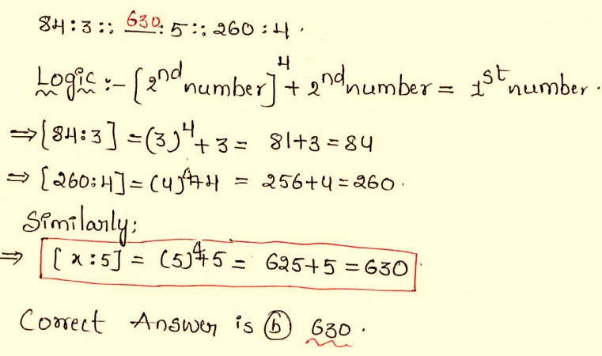

12) Find the number of triangles in the given figure.

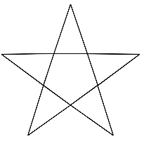

a) 8

b) 10

c) 12

d) 15

Ans. b

Sol.

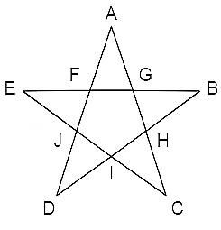

Name of triangles formed are:

AFG, BGH, CHI, JDI, EFJ.

CAJ, CEG, BEI, DBF, DAH

Total number of triangles in the given figure = 10.

Hence, option C is correct.

13) If a mirror is placed on the line PQ, which of the answer figures is the correct image of the given question figure?

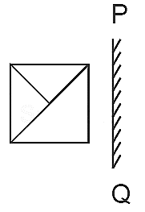

a) 

b) 

c) 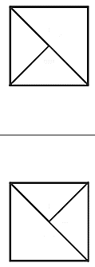

d) 

Ans. d

Sol.

The correct mirror image of the given image in the question figure is,

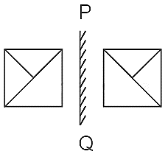

Hence, option D is correct.

14) Read the given information carefully and answer the question that follows.

U is the brother of A. X is the daughter of A. K is the wife of A. G is the son of X. How is A is related to G?

a) Maternal Uncle

b) Maternal Grandfather

c) Paternal Grandfather

d) Cannot be determined

Ans. b

Sol.

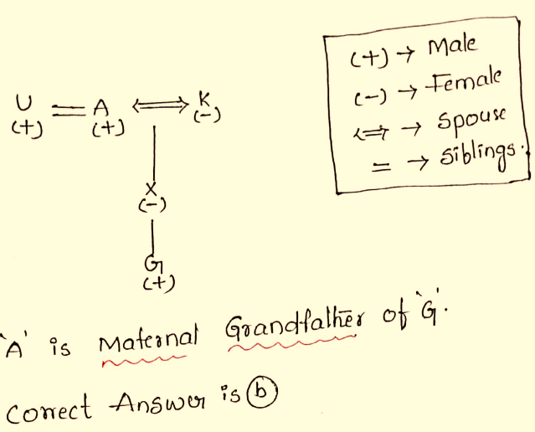

15) Which Answer Figure will complete the pattern in the figure?

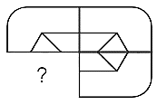

a) 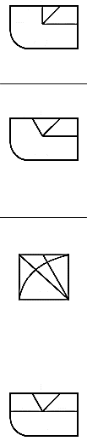

b) 

c) 

d) 

Ans. b

Sol.

On close observation we get, option B completes the pattern given in the figure

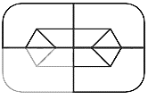

Hence, option B is correct.

16) Study the given diagram carefully and answer the question that follows. The numbers in different sections indicate the number of students who like particular subjects.

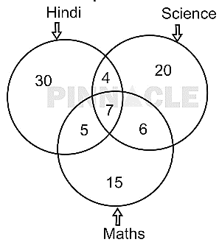

How many students like Hindi and Science both, but NOT Maths?

a) 12

b) 11

c) 4

d) 10

Ans. c

Sol.

No. of students like Hindi and Science both but not maths = 4

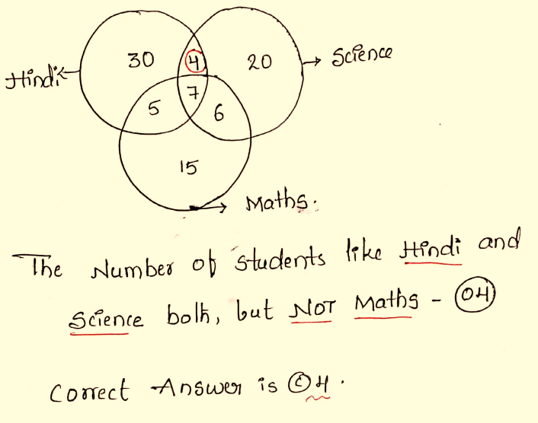

17) In a certain code language, ‘**mix jaggery well**’ is written as ‘**rb co ot**’ and ‘**well done boss**’ is written as ‘**cx rb op**’. How is ‘**well**’ written in the given language?

a) co

b) cx

c) rb

d) ot

Ans. c

Sol.

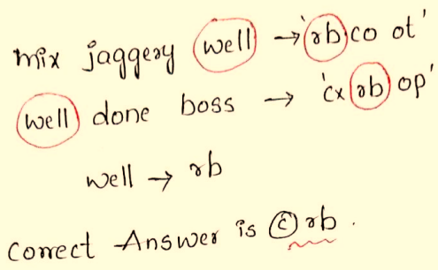

18) If 4 December 2014 was Thursday, then what was the day of the week on 10 December 2018?

a) Monday

b) Tuesday

c) Wednesday

d) Friday

Ans. a

Sol.

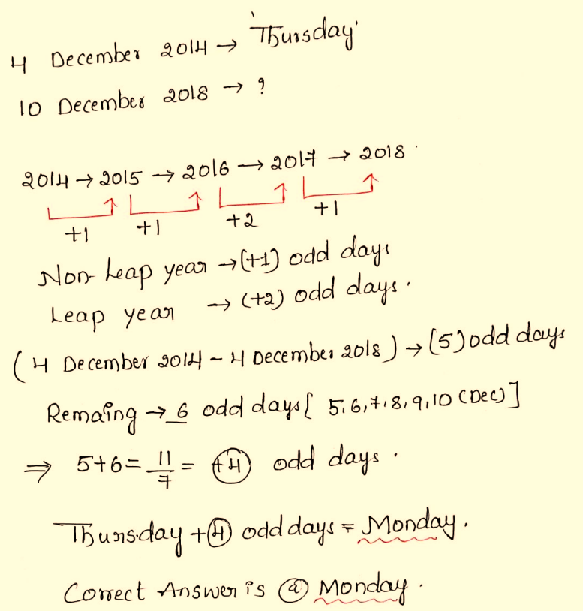

19) Which of the following letter-clusters should replace # and % so that the pattern and relationship followed between the letter-cluster pair on the left side of :: is the same as that on the right side of :: ?

**# : VXB :: ACG : %**

a) # - GIM, % - KMQ

b) # - UVN, % - KMQ

c) # - HDN, % - BDH

d) # - UWA, % - BDH

Ans. d

Sol.

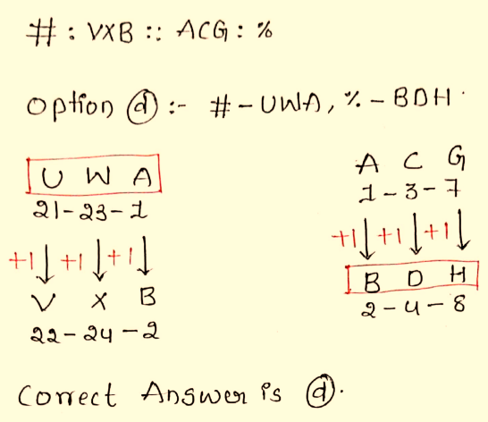

20) Q is the mother of T. R is the husband of P. S is the father of Q. T is the brother of P. How is P related to S?

a) Daughter’s daughter

b) Mother’s mother

c) Mother’s father

d) Brother’s wife

Ans. a

Sol.

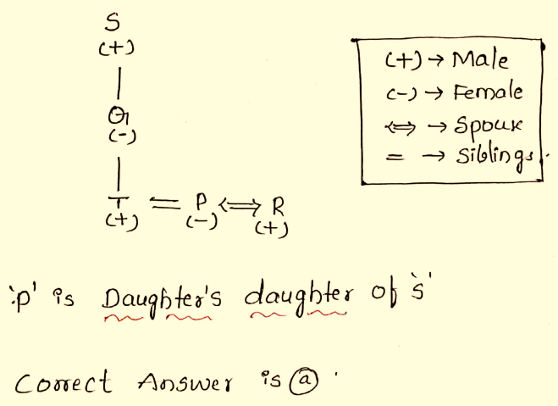

21) Find the correct combination of letters that when sequentially filled in the blanks of the given series will make the series logically complete.

**ABF_HI_NOP_U_WABCDH_**

a) GMTUI

b) IMTVI

c) GMSVI

d) GMTVI

Ans. d

Sol.

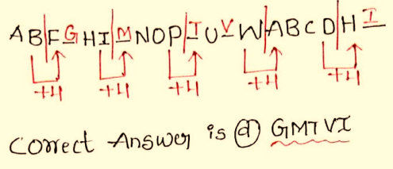

22) Find the missing character in the following question.

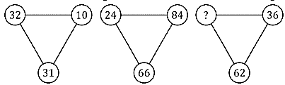

a) 24

b) 62

c) 36

d) 44

Ans. c

Sol.

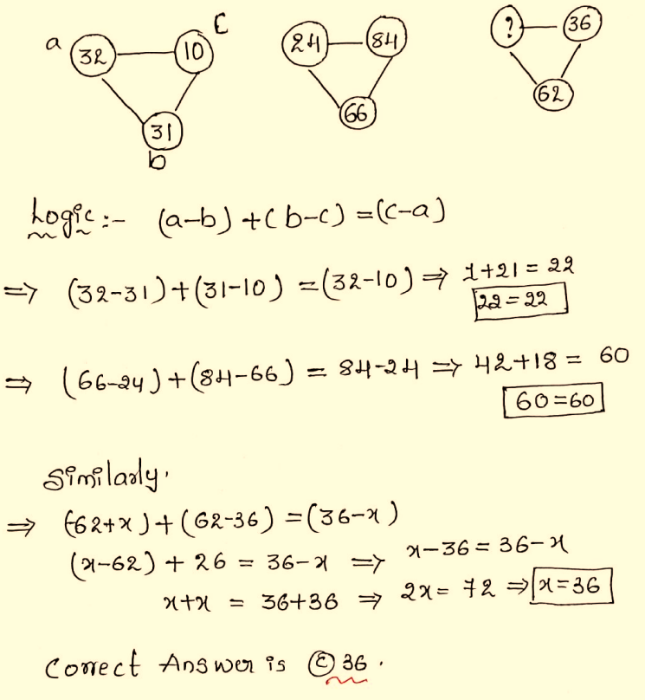

23) Arrange the given words in the order in which they occur in the dictionary.

1. Dollar

2. Doll

3. Dominos

4. Donkey

5. Dealer

a) 5, 2, 1, 3, 4

b) 2, 1, 3, 4, 5

c) 3, 1, 4, 5, 2

d) 5, 4, 3, 2, 1

Ans. a

Sol.

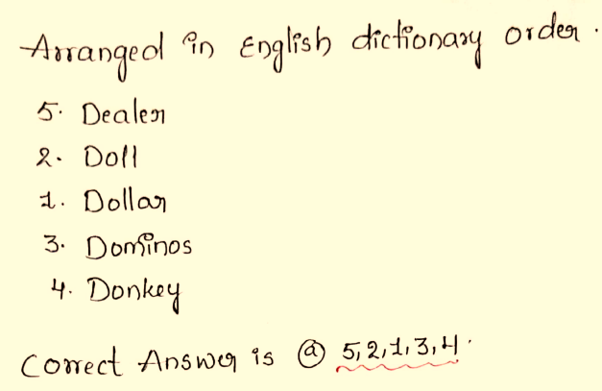

24) Arrange the letters and form a meaningful word.



a) 156234

b) 621345

c) 345621

d) 416235

Ans. b

Sol.

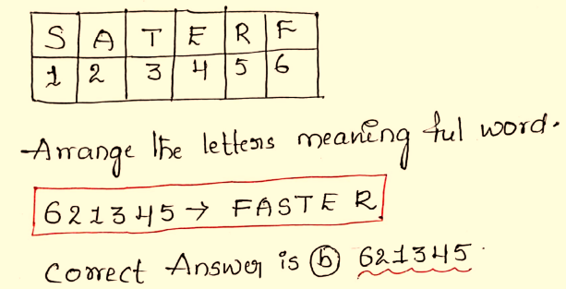

25) If A represents ‘+’, B represents ‘-’, C represents ‘×’, and D represents ‘÷’, then find the value of the given equation?

**216D18C9A5B12**

a) 110

b) 101

c) 103

d) 108

Ans. b

Sol.

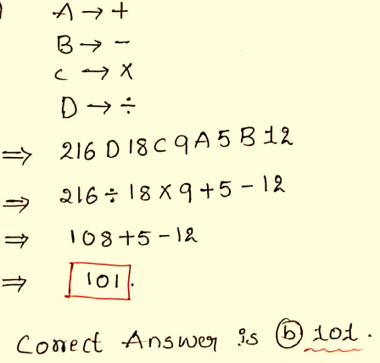

26) What is the percentage composition of the element of H₂SO₃?

a) 2.5% H, 58.5% S, 39% O

b) 33% H, 16% S, 51% O

c) 58.5% H, 39% S, 2.5% O

d) 2.5% H, 39% S, 58.5% O

Ans. d

Sol.

27) Which of the following was established on the recommendation of the Hilton Young Commission?

a) SEBI

b) RBI

c) SBI

d) NABARD

Ans. b

Sol.

28) The Olympic Games are held every __________.

a) Fifth year

b) Third year

c) Fourth year

d) Second year

Ans. c

Sol.

29) “Amatya” in the Saptang Theory of Kautilya denotes which of the following?

a) Friend

b) Minister and Officials

c) Fort

d) Territory

Ans. b

Sol.

30) Which five-year plan emphasised on the development of industries and industrial base in India?

a) Second

b) Fourth

c) Third

d) First

Ans. a

Sol.

31) In which city of Assam is the Tea Festival celebrated every year?

a) Guwahati

b) Silchar

c) Jorhat

d) Dibrugarh

Ans. c

Sol.

32) Which of the following pairs is INCORRECTLY matched?

a) Bryophyta — Moss

b) Angiosperms — Rose

c) Pteridophyta — Cycas

d) Gymnosperms — Pinus

Ans. c

Sol.

33) India can be considered to be a country with Demographic Dividend due to _______________.

a) High population above 70 years

b) High population between 15- 64 years

c) High population between 10-20 years

d) High total population below 15 years

Ans. b

Sol.

34) In which country was the U23 “Asian Wrestling Championship 2025 recently organized?

a) Singapore

b) Malaysia

c) India

d) Vietnam

Ans. d

Sol.

35) The famous musician, Faiyaz Khan is associated with which musical Instrument?

a) Shehnai

b) Veena

c) Tabla

d) Sitar

Ans. c

Sol.

36) The Raigarh Gharana is associated with which of the following dance forms?

a) Odissi

b) Kathakali

c) Kathak

d) Manipuri

Ans. c

Sol.

37) What is the name of the flagship program that was launched in 2005 to address the lack of infrastructure in urban India?

a) National Urban Livelihoods Mission

b) Integrated Development of Small & Medium Towns

c) Atal Mission for Rejuvenation and Urban Transformation

d) Jawaharlal Nehru National Urban Renewal Mission

Ans. d

Sol.

38) How many medals won by Indian athletes at the “2025 Asian para badminton Championship”?

a) 22

b) 25

c) 27

d) 30

Ans. c

Sol.

39) Which state is also known as the ‘Molasses basin’, which is made up of soft unconsolidated deposits?

a) Mizoram

b) Manipur

c) Nagaland

d) Meghalaya

Ans. a

Sol.

40) Justice Indu Malhotra penned a dissenting opinion in which of the following landmark Judgements?

a) Basic structure doctrine

b) Preamble part of the Constitution

c) Entry of women to Sabarimala

d) Land reforms in India

Ans. c

Sol.

41) Which state has become the third fully literate state of India?

a) Goa

b) Tripura

c) Mizoram

d) Maharashtra

Ans. b

Sol.

42) Who among the following leaders from INC attended the Second Round Table Conference?

a) Mahatma Gandhi

b) Subhash Chandra Bose

c) Sucheta Kripalani

d) Jawaharlal Nehru

Ans. a

Sol.

43) 2031 ODI World Cup will be held in India and _____.

a) Sri Lanka

b) Afghanistan

c) Pakistan

d) Bangladesh

Ans. d

Sol.

44) What is 14th Maharatna Company in India?

a) CIL

b) HAL

c) ONGC

d) OIL

Ans. b

Sol.

45) Through which of the following organisations did Annie Besant promote the studies of ancient Indian religions, philosophies and doctrines?

a) Arya Samaj

b) Theosophical Society

c) Paramhans Mandali

d) Prarthana Samaj

Ans. b

Sol.

46) The Chairman of a State Public Service Commission can be removed by the order of the ________

a) Prime Minister

b) President

c) Governor

d) Chief Minister

Ans. b

Sol.

47) What type of vegetation is found in the plateau of Meghalaya, Sahyadri and the central and southern islands of the Nicobar group?

a) Dry Tropical Deciduous Vegetation

b) Dry Tropical Thorny Vegetation

c) Alphine Vegetation

d) Moist Tropical Semi-Evergreen Vegetation

Ans. d

Sol.

48) In case an Indian citizen is arrested and denied the right to be defended, then in such a situation, which Article of the Indian Constitution can provide a relief?

a) Article 22

b) Article 23

c) Article 25

d) Article 24

Ans. a

Sol.

49) Which of the following helps the coffee flowers to blossom in Karnataka?

a) Norwesters

b) Loo

c) Mango shower

d) Blossom shower

Ans. d

Sol.

50) Tila, Seti and Beri are the tributaries of which river?

a) Tamsa

b) Ghaghara

c) Mahi

d) Sabarmati

Ans. b

Sol.

51) If , then the value of $\cos^{4}{+cos²}$ is:

a) 1

b) 0

c) 2

d) -1

Ans. a

Sol.

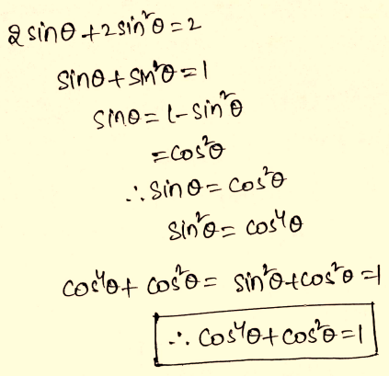

52) If , then find the value of T:

a) 6596

b) 6945

c) 7335

d) 7569

Ans. b

Sol.

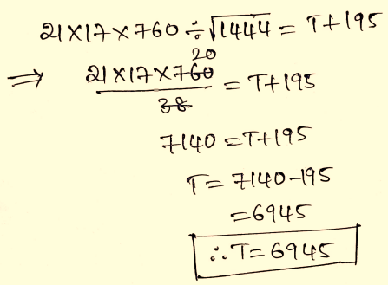

53) If a + b + c = 7, $a^{3}+b^{3}+c^{3}=119$ and abc = 35, then find the value of $a^{2}+b^{2}+c^{2}-ab-bc-ca$:

a) 7

b) 2

c) 5

d) $\frac{2}{7}$

Ans. b

Sol.

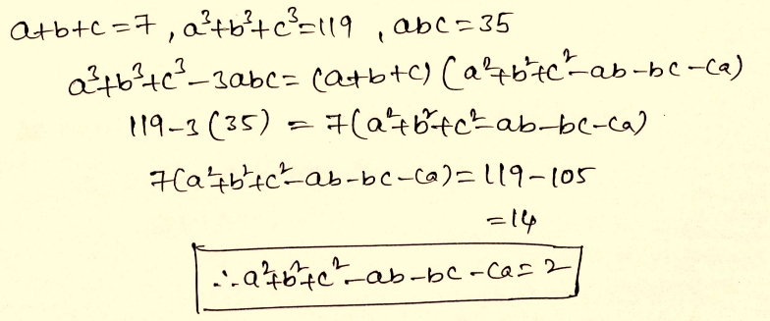

54) In an election between two candidates, 85% of the voters cast their vote out of which 127 votes were declared invalid. The winner got 51% of all the voters in the list and he won by 7777 votes. The number of voters on the list was:

a) 50000

b) 45000

c) 42000

d) 40000

Ans. b

Sol.

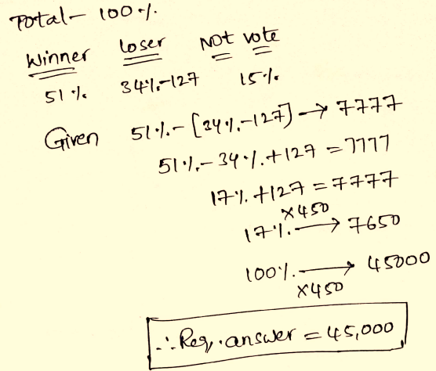

55) To obtain a mixture valued at Rs.205.50 per kg, in what ratio should a grocer combine two types of pulses that cost Rs.203 per kg and Rs.215 per kg, respectively?

a) $19:5$

b) $5:17$

c) $14:5$

d) $5:19$

Ans. a

Sol.

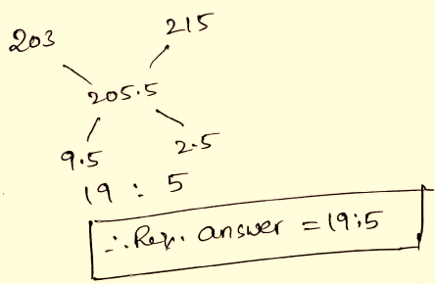

56) 20 men begin to do work. But after some days, 10 of them left the job. As a result, the job that could have been completed in 40 days is completed in 50 days. How many days after the commencement of the work did the 10 men leave?

a) 20

b) 25

c) 30

d) 18

Ans. c

Sol.

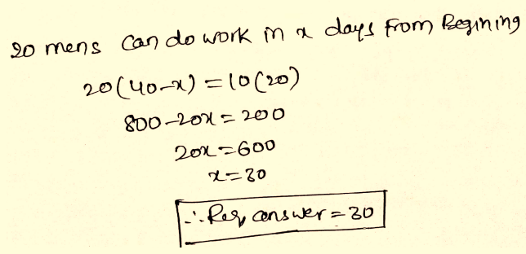

57) Three circles of radius 14 cm are kept touching each other. The string is tightly tied around these three circles. What is the length of the sting?

a) $84+28$

b) $42+28$

c) $84+14$

d) $42+14$

Ans. a

Sol.

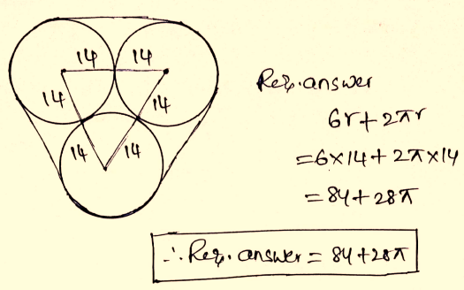

58) Reena and Amit together invested Rs. 89600 in a business. At the end of the year, out of a total profit of Rs. 9000, Reena’s share was Rs. 3645. What was the investment of Amit?

a) 48326

b) 53312

c) 36288

d) 44586

Ans. b

Sol.

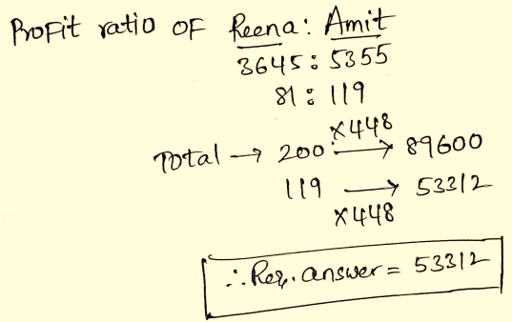

59) The median of a set of 11 distinct observations is 73.2. If each of the largest five observations of the set is increased by 3, then the median of the new set:

a) is 3 times that of the original set

b) is increased by 3

c) remains the same as that of the original set

d) is decreased by 3

Ans. c

Sol.

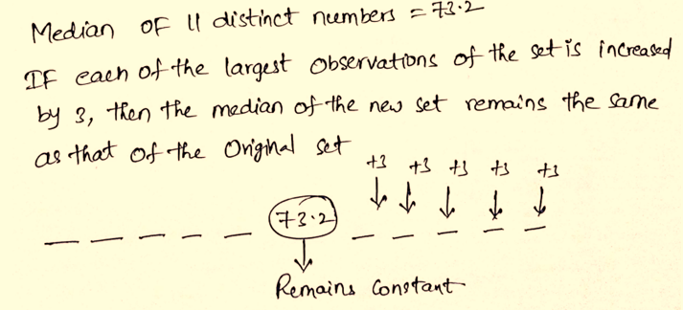

60) A truck covers a distance of 360 km at a certain speed. If the speed is decreased by 15 km/h, it will take 4 hours more to cover the same distance. Find 60% of its original speed (in km/h).

a) 45

b) 27

c) 54

d) 75

Ans. b

Sol.

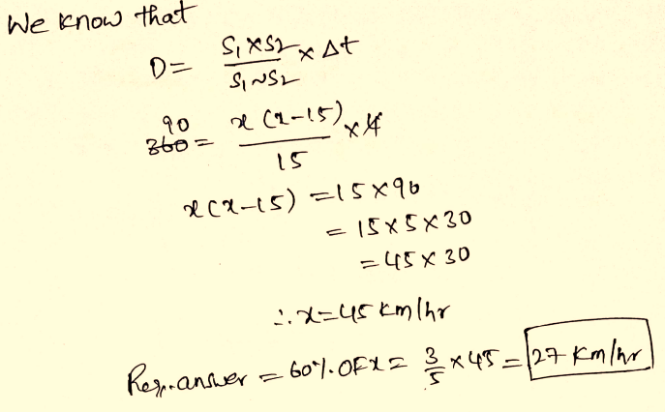

61) The ratio of the ages of A and B, five years ago, was 3:4. Seven years from now, the ratio of their ages will be 5:6. What is the sum of their present ages?

a) 52 years

b) 48 years

c) 56 years

d) 60 years

Ans. a

Sol.

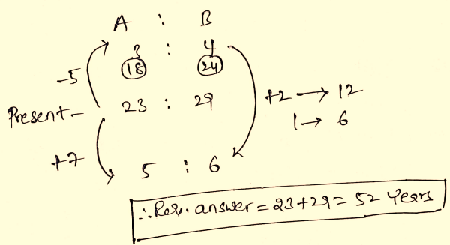

62) In , F and E are the points on sides AB and AC, respectively, such that FE || BC and FE divides the triangle in two parts of equal area. If AD ⊥ BC and AD intersects FE at G, then GD:AG = ?

a) $\sqrt{2}:1$

b) $\left(\sqrt{2}-1\right):1$

c) $2\sqrt{2}:1$

d) $1:(\sqrt{2}-1)$

Ans. b

Sol.

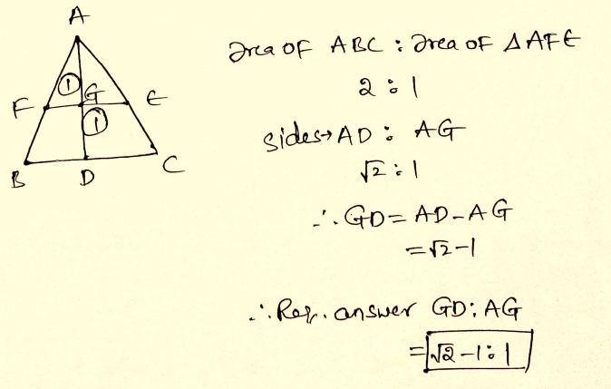

63) Calculate the variance from the following data.

**3, 6, 5, 2, 4**

a) 3

b) 2

c) 2.2

d) 2.5

Ans. b

Sol.

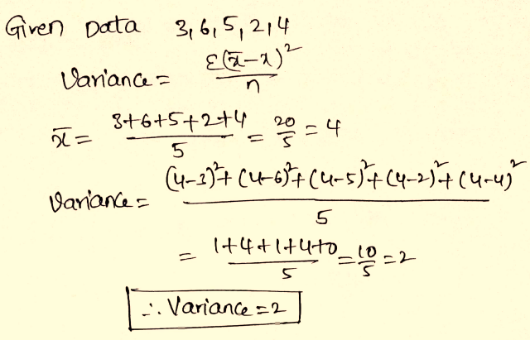

64) If a nine-digit number 846a2591b is divisible by 72, then the value of (5a – 2b) is:

a) 34

b) 35

c) 36

d) 37

Ans. c

Sol.

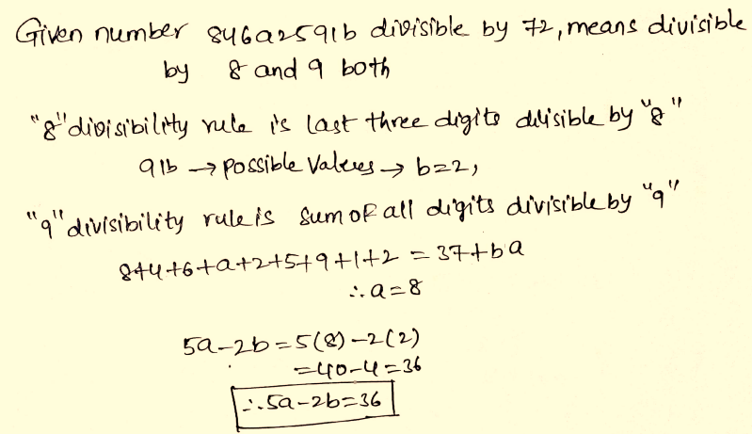

65) If decreasing 200 by y% gives the same result as increasing 50 by y%, then y% of 250 is what percent more/less than (y + 20)% of 150?

a) 35

b) 30

c) 25

d) 40

Ans. c

Sol.

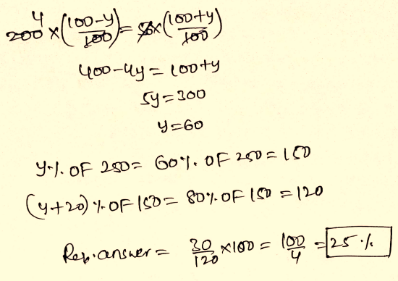

66) If then cos A is equal to:

a)

b)

c)

d)

Ans. a

Sol.

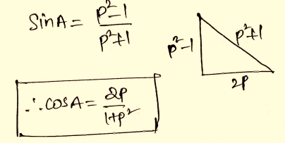

67) A bag contains tickets numbered from 1 to 15. Two tickets are drawn. The probability that both numbers are prime, is?

a) $\frac{1}{5}$

b) $\frac{1}{7}$

c) $\frac{1}{9}$

d) $\frac{1}{12}$

Ans. b

Sol.

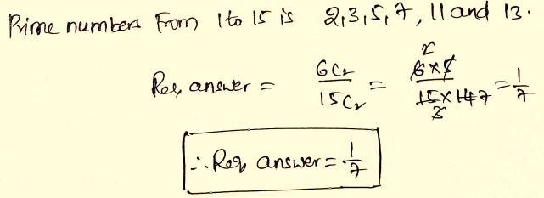

68) If , then the value of $x^{2}-5x$ is:

a) -1

b) 1

c) 0

d) 5

Ans. a

Sol.

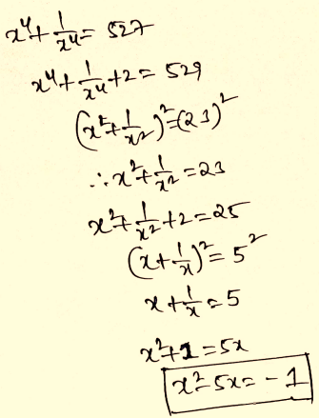

69) x and y are two numbers having opposite signs such that, $x^{2}:y^{2}=49:64$. What is the value of (5x – 6y):(6x – 7y)?

a) 44:65

b) 13:14

c) 94:117

d) 83:98

Ans. d

Sol.

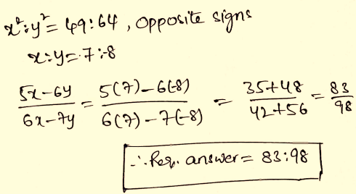

70) A certain amount of money becomes thrice in 5 years at compound interest. How many years it will take to become 9 times?

a) 15 years

b) 8 years

c) 10 years

d) 25 years

Ans. c

Sol.

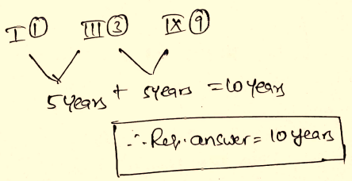

71) If average of 14 consecutive even numbers is 107. Then, find the smallest number?

a) 93

b) 94

c) 92

d) 89

Ans. b

Sol.

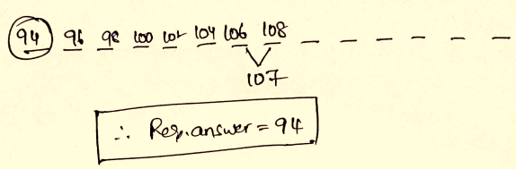

72) If 50 bananas be sold for Rs.160 at a loss of 20%. How many bananas should he sell for Rs. 1,540 so as to make 10% profit?

a) 320

b) 300

c) 360

d) 350

Ans. d

Sol.

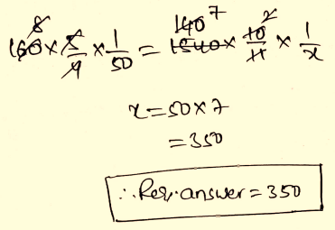

73) The difference between circumference and the diameter of a circle is 120 cm. What is the area of the circle?

a) 1386 cm²

b) 2464 cm²

c) 3256 cm²

d) 2310 cm²

Ans. b

Sol.

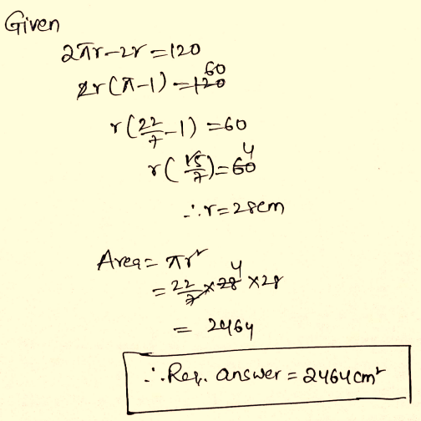

74) In a triangle ABC, AB = 21 cm, BC = 20 cm and CA = 13 cm. a perpendicular CD is drawn upon the longest side. What is the area of the triangle BCD?

a) 84 sq cm

b) 96 sq cm

c) 80 sq cm

d) 72 sq cm

Ans. b

Sol.

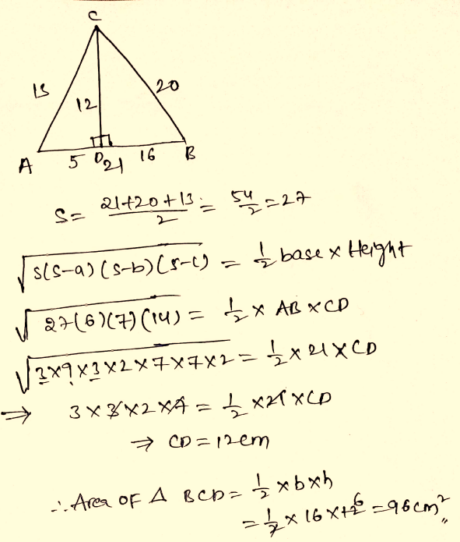

75) Find the length of longest pole that can be placed in a room 16 m long, 8m board, 11m high?

a) 20

b) 21

c) 18

d) 19

Ans. b

Sol.

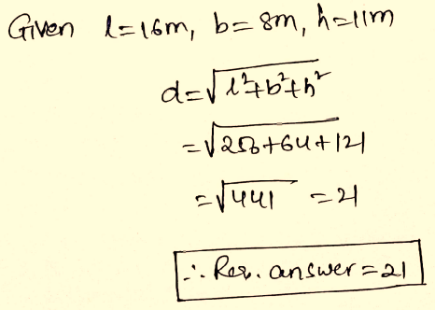

76) Identify the segment in the sentence which contains the grammatical error. If there is no error, select 'No error'

Those who are late they will not be allowed in the classroom.

a) in the classroom

b) they will not be allowed

c) Those who are late

d) No error

Ans. b

Sol.

The correct answer is option b i.e. they will not be allowed.

The sentence uses a pronoun 'those' as a term to refer to people, thus another pronoun - they - is unnecessary and should be removed from the sentence.

The correct answer is option b.

77) Select the option that can be used as a one-word substitute for the given group of words/phrase.

Having two opposing feelings at the same time.

a) Coinciding

b) Ambivalent

c) Equivalent

d) Contemporary

Ans. b

Sol.

The correct answer is ambivalent

**Key Points:**

**Ambivalent**: Refers to someone who has opposing or contradictory feelings about something

Let's look at the meaning of the other words:

**Coinciding**: Refers to 2 things that happen together, and they are unplanned

**Equivalent**: Refers to 2 or more things that are equal

**Contemporary**: Refers to something that is living and occurring at the same time

Thus the correct answer is option b.

78) Select the most appropriate option to substitute the underlined segment in the given sentence. If there is no need to substitute it, select No improvement.

We came back because we had ran out of money.

a) No improvement

b) we had run

c) we run

d) we have ran

Ans. b

Sol.

The correct answer is we had run

**Key Points:**

Here the past perfect tense is used, and we know that with 'had' we should use the third form of the verb. Here the verb used is 'ran' which is the past form but we need past participle (V3). So 'ran' must be replaced with 'run'.

If you run out of something, you have no more of it left.

Examples:

They have run out of ideas.

We're running out of time.

By now the plane was running out of fuel.

We had lots before but now we've run out.

Thus, the correct sentence is: We came back because we had run out of money.

79) Select the most appropriate ANTONYM of the given word.

Persist

a) Insist

b) Remain

c) Cease

d) Continue

Ans. c

Sol.

The correct answer is option c i.e. cease

**Persist**: Refers to someone who does not give up

**Cease**: Refers to someone who stops

Thus, it is clear that persist and cease are opposite words

Let's look at the meaning of the other words:

**Insist**: Refers to someone who demands something forcefully

**Remain**: Refers to someone who stays back

**Continues**: Refers to someone who goes on

Thus, the correct answer is option c.

80) Select the correct passive form of the given sentence.

The farmer is ploughing the fields.

a) The fields have been ploughed by the farmer.

b) The fields are being ploughed by the farmer.

c) The fields were ploughed by the farmer.

d) The fields are ploughed by the farmer.

Ans. b

Sol.

The correct answer is The fields are being ploughed by the farmer.

**Key Points:**

In Active Voice, a sentence emphasizes the subject, performing an action.

In Passive Voice, a sentence emphasizes the action or the object of the sentence.

The given sentence is in the active voice and 'The farmer' is the subject and 'the fields' is the object.

When we convert this sentence into passive voice, the subject 'The farmer' of the active voice becomes the object, the object 'the fields' becomes the subject.

The passive format "are + being + V3 (ploughed)" should be used.

This is the active and passive voice rule for the present continuous tense.

Hence, the correct answer is option b.

**Additional Information:**

Verbs of passive format have a different set of tenses (*V3 - Past participle or Third form of the Verb) as given below in the table:

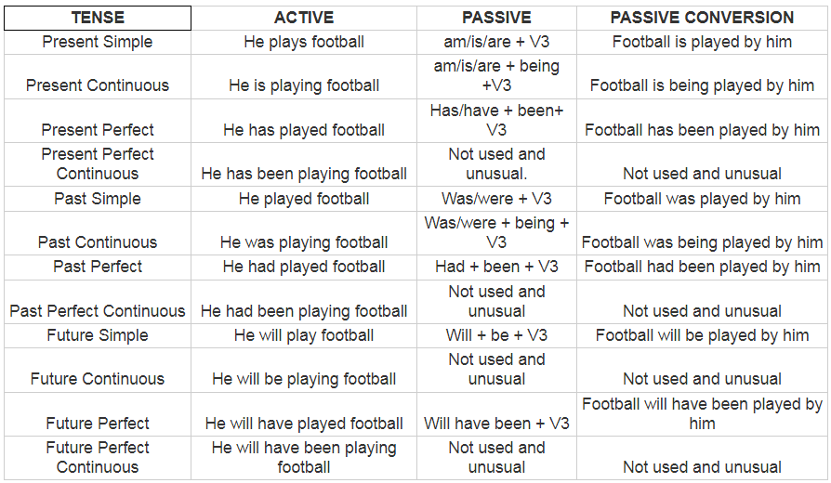

81) Select the correct indirect form of the given sentence.

“What a rare flower!” she said.

a) She exclaimed that it was a very rare flower.

b) She told that what a rare flower it was.

c) She exclaimed what a rare flower it is.

d) She asked if it was a rare flower.

Ans. a

Sol.

The correct answer is option a i.e. She exclaimed that it was a very rare flower.

The original sentence contains an exclamation point, thus the reported speech should incorporate this. Thus, option b and d cannot be used here as they use the verbs told and asked respectively. Option c uses present tense and reported speech should be in the past tense, option c uses the verb 'is' in the present tense and thus cannot be the answer.

Thus, the correct answer is option a.

D-X)

**Direction:** In the following passage, some words have been deleted. Fill in the blanks with the help of the alternatives given. Select the most appropriate option for each blank. Each blank is alphabetized.

Atlas was made to hold the sky up on his shoulders as a punishment. Once, Hercules (A)______ to hold it for Atlas while the latter went looking (B)______ golden apples. When Atlas returned, he saw Hercules (C)______ hard to hold the sky. The weight of the sky (D)______ Hercules sweat and groan. Now Atlas did not want to (E)______ a job as arduous as that!

82) A.

a) afforded

b) ordered

c) offered

d) extended

Ans. c

Sol.

The correct answer is option c i.e. offered

The passage talks about Atlas holding up the world on his shoulders. One cannot 'afford' to hold something for someone, thus option a is wrong. One cannot 'order' themselves to do something, they can order someone else to do something, thus option b is incorrect. Option d is incorrect because one cannot extend 'to' something.

Thus, the correct answer is option c.

83) B.

a) for

b) on

c) at

d) after

Ans. a

Sol.

The correct answer is option a i.e. for

Look for is a phrasal verb which means attempt to find someone or something.

Thus, the work that fits in blank 2 in the sentence is 'for'- the latter went looking (b)______ golden apples.

The sentence mentions looking for apples, things cannot be looked 'on', thus option b is incorrect. One cannot 'went looking at' something, thus option c is incorrect. Option d is incorrect because one cannot 'went looking after' apples.

Thus, the correct answer is option a.

84) C.

a) coping

b) struggling

c) tackling

d) seeking

Ans. b

Sol.

The correct answer is option b i.e. struggling

One cannot be 'tackling' hard, thus option c is incorrect. Option a is incorrect because does not 'cope' hard to hold up the sky. Option d is incorrect because one cannot 'seek' hard to hold up the sky.

Thus, the correct answer is option b.

85) D.

a) was making

b) has made

c) were making

d) make

Ans. a

Sol.

The correct answer is option a i.e. was making

The sentence is in the past tense as it is in reported speech. Thus, option b and d cannot be correct as they are in the present tense. Option c is incorrect as there is only one sky - singular - thus the verb should also be singular and 'were' is a plural verb and so cannot be in the answer.

Thus, the correct answer is option a.

86) E.

a) take back

b) take out

c) take away

d) take in

Ans. a

Sol.

The correct answer is option a i.e. take back

The passage shows that Atlas holds up the sky, and Hercules offers to hold it up for a while and he is groaning and sweating meaning that it is not a pleasant job. Thus, this is not a job Atlas would want to 'take back' thus option c is incorrect. A job is not an entity that can be 'taken out' and neither can it be taken 'in'.

Thus, the correct answer is option a.

##End Essay

87) Select the most appropriate option to fill in the blank.

The roof of the old building ______ during the storm.

a) destroyed

b) scratched

c) demolished

d) collapsed

Ans. d

Sol.

The correct answer is option d i.e. collapsed

**Key Points:**

Option a is incorrect because a roof is not an entity that can 'destroy'.

Option b is incorrect because 'scratched' needs to have the verb 'be' before it.

Option c is incorrect because it is missing the verb 'was'.

Option d is correct because 'collapsed' means fell down/broke apart, which fits in here as per the grammatical context.

Thus, the correct answer is option d.

88) Select the most appropriate option to substitute the underlined segment in the given sentence. If there is no need to substitute it, select No improvement.

When it started raining, I ran to the nearer house for shelter.

a) a near house

b) the near house

c) No improvement

d) the nearest house

Ans. d

Sol.

The correct answer is option d i.e. the nearest house

The sentence refers to only one house, the term 'nearer' is a comparative term which is used only where there are 2 entities to compare. Thus, the sentence needs to replace 'nearer' with a superlative term 'nearest'.

Thus, the correct answer is option d.

89) Select the wrongly spelt word.

a) Sieze

b) Fierce

c) Piece

d) Grief

Ans. a

Sol.

The correct answer is sieze

**Key Points:**

The correct spelling is 'seize'. When a group of people seize a place or seize control of it, they take control of it quickly and suddenly, using force.

**Fierce**: A fierce animal or person is very aggressive or angry.

**Piece**: A piece of something is an amount of it that has been broken off, torn off, or cut off.

**Grief**: Grief is a feeling of extreme sadness.

90) Identify the segment in the sentence which contains the grammatical error. If there is no error, select 'No error'

Everyone except she have travelled by air.

a) Everyone except

b) No error

c) she have

d) travelled by air

Ans. c

Sol.

The correct answer is she have

**Key Points:**

If the subjects are joined by 'as well as', 'with', 'along with', 'together with', 'and not', 'besides', 'except' etc, the verb will agree with the first subject. As 'Everyone' is an indefinite singular pronoun, so singular verb will be used.

Except is a preposition here and it will be followed by the objective case of pronoun, so 'her' should be there in place of 'she'.

Thus, the correct answer is option c.

The correct sentence is: Everyone except her has travelled by air.

91) Select the option that can be used as a one-word substitute for the given group of words/phrase.

A group of ships

a) fleet

b) colony

c) swarm

d) squad

Ans. a

Sol.

The correct answer is fleet

**Key Points:**

**Fleet**: A collective term for a group of ships

**Colony**: Refers to territory under the control of people that are not from there

**Swarm**: A collective term for a group of bees

**Squad**: A collective term for a group with a common goal

Thus, the correct answer is option a.

92) Select the most appropriate ANTONYM of the given word.

Glee

a) Woe

b) Bliss

c) Joy

d) Fun

Ans. a

Sol.

The correct answer is "Woe".

**Key Points:**

Glee refers to great delight or joy.

Woe is the correct antonym, which refers to great sorrow or distress.

Therefore, the correct answer is "Option a".

**Additional Information:**

Bliss is a state of perfect happiness or joy, which is similar in meaning to glee.

Joy refers to a feeling of great pleasure and happiness., making it synonymous with glee.

Fun denotes enjoyment, amusement, or light-hearted pleasure.

93) Select the most appropriate synonym of the given word.

Ovation

a) Preparation

b) Censure

c) Creation

d) Applause

Ans. d

Sol.

The correct answer is 'Applause'.

**Key Points:**

**Ovation**: Refers to a sustained show of appreciation through applause

**Applause**: Approval or praise through clapping

Thus, it is clear that ovation and applause are similar words

**Preparation**: The process of being prepared for something

**Censure**: Refers to severe disapproval by someone

**Creation**: Refers to the act of producing something

94) Given below are four jumbled sentences. Out of the given options pick the one that gives their correct order.

A. Much of this war had taken place along the Western Front.

B. Both sides had dug in deep and each lost many men over little ground.

C. This front was a line of trenches across which the two sides faced each other.

D. Andre Maginot had fought a war with the French against the Germans.

a) ACDB

b) BCDA

c) DACB

d) DBCA

Ans. c

Sol.

The correct answer is option c i.e. DACB

The passage begins with statement D which introduces the topic at hand - Andre Maginot's fight against the Germans. This is followed by statement A which talks about the war in detail - the Western Front as the location, the comes statement C which talks about the Western Front in further detail and finally comes statement B which talks about how the men on either side dealt with the terrain.

Thus, the correct answer is option c.

95) Select the most appropriate meaning of the given idiom.

Chicken-hearted

a) Cowardly

b) Generous

c) Miserly

d) Selfish

Ans. a

Sol.

The correct answer is option a i.e. cowardly

The idiom 'chicken-hearted' refers to someone who is scared easily or is a coward

Thus, the correct answer is option a.

96) Select the most appropriate meaning of the given idiom.

By and by

a) Suddenly

b) Gradually

c) By any means

d) On the whole

Ans. b

Sol.

The correct answer is option b i.e. gradually

The idiom 'by and by' refers to something that happens slowly and eventually.

Thus, the correct answer is option b.

97) Select the most appropriate option to fill in the blank.

She ______ how the magician had performed the rope trick.

a) suspected

b) wondered

c) bewildered

d) puzzled

Ans. b

Sol.

The correct answer is wondered

**Key Points:**

Meaning of the words given in the options are:

**Suspected**: believed guilty of an offense

**Wondered**: to have curiosity or doubt about; want to know

**Bewildered**: If you are bewildered, you are very confused and cannot understand something or decide what you should do.

**Puzzled**: Someone who is puzzled is confused because they do not understand something.

Thus, the correct answer is option .

98) Select the INCORRECTLY spelt word.

a) Acquaintence

b) Abandon

c) Alliance

d) Acquisition

Ans. a

Sol.

The correct answer is option a i.e. Acquaintence

**Key Points:**

The correct spelling would be 'acquaintance'

**Acquaintance**: a person one knows slightly, but who is not a close friend.

**Additional Information:**

**Abandon**: Cease to support or look after.

**Alliance**: A union or association formed for mutual benefit, especially between countries or organizations.

**Acquisition**: An asset or object bought or obtained, typically by a library or museum.

Thus, the correct answer is option a.

99) Select the most appropriate synonym of the given word.

Preferred

a) Compared

b) Adored

c) Feared

d) Favoured

Ans. d

Sol.

The correct answer is option 4 i.e. favoured

**Preferred**: Refers to someone who is recommended

**Favoured**: Refers to someone who is liked more than others

Thus, it is clear that preferred and favoured are similar words

**Compared**: Refers to someone who is measured in terms of someone else

**Adored**: Refers to someone who is loved and admired

**Feared**: Refers to someone who is scary

Thus, the correct answer is option d.

100) Given below are four jumbled sentences. Out of the given options pick the one that gives their correct order.

A. The mountain range was covered with snow.

B. Napoleon had to cross the Alps in winter.

C. Napoleon replied that the word 'impossible' did not exist for him.

D. So, someone told Napoleon that the task was impossible

a) ADBC

b) DBCA

c) BADC

d) BDCA

Ans. c

Sol.

The correct answer is option c i.e. BADC

The passage begins with an introduction to the topic at hand - statement B - how Napoleon had to cross the Alps in winter. This is followed by statement A, this describes the mountain range. Then comes statement D which talks about how Napoleon was told by someone the task was impossible, then comes statement C which talks about Napoleon's response to the friend - the word 'impossible' did not xist for him.

Thus, the correct answer is option c.